 | Mehran University of Engineering and Technology, Khairpur  Department of Software Engineering

Course: SWE-Computer Network Practical
Instructor |  | Dr. Asad Raza Malik |  |  | Practical/Lab No. |  |  | 01
Date |  | 12-12-2025 |  |  | CLOs |  |  | 03
Student’s Roll no: |  |  |  |  | Point Scored:
Date of Conduct: |  | 12-12-2025 |  |  | Teacher’s Signature:
LAB PERFORMANCE INDICATOR | Subject Knowledge |  | Data Analysis and Interpretation | Ability to Conduct Experiment |  | Presentation | Calculation and Coding |  | Observation/ Result | Score

Topic | To Work with cable specification, installation, and troubleshooting
Objective | By the end of this lab, students will be able to:  - Identify and compare different types of modern network cables and their specifications (Cat5e, Cat6, Cat6a, Cat7, Cat8, Fiber).  - Perform proper installation and termination of twisted-pair cables using RJ45 connectors according to T568A/T568B standards.  - Understand structured cabling concepts used in modern enterprises (horizontal cabling, backbone cabling, patch panels, labeling).  - Use basic and advanced tools for testing and troubleshooting network cables (simple cable tester, Fluke-type certifier, basic fiber inspection).  - Set up a small wired LAN and verify connectivity using standard tools (ping, ipconfig, etc.)
Materials Required: | - Cables  - Twisted Pair Copper Cables:  - Cat5e (up to 1 Gbps, 100 m)  - Cat6 (up to 1–10 Gbps, 55 m @10G)  - Cat6a (up to 10 Gbps, 100 m)  - Cat7 / Cat7a (shielded, 10 Gbps, 100 m – data centers)  - Cat8 (up to 25/40 Gbps, ~30 m – server rooms)  - Coaxial Cables (for legacy/illustration only)  - Fiber Optic Cables:  - Single-mode OS2  - Multimode OM3 / OM4 patch cords  - Connectors & Passive Components  - RJ45 connectors (for Cat5e/Cat6/Cat6a)  - Keystone jacks and patch panels (for structured cabling demo)  - Fiber connectors / patch cords: LC, SC, and MPO/MTP (for demonstration)  - Tools & Equipment  - Crimping tool for RJ45  - Wire stripper and cable cutter  - Punch-down tool (for keystone jacks / patch panel)  - Basic network cable tester (for continuity and pin-out check)  - Optional advanced tools (demonstration only):  - Fluke DSX/DTX or similar cable certifier  - Simple OTDR / fiber inspection microscope (if available)  - Network switch (Fast/Gigabit switch)  - Wi-Fi 6/6E router or access point (optional comparison with wired)  - 2–3 computers / laptops with network interface cards (NICs)  - Screwdrivers, labels, and marker pens
Lab Discussion: Theoretical concepts and Procedural steps
Theory:
What is Network Cabling?
Network cabling is the physical layer infrastructure that carries data between computers, switches, routers, servers and other network devices in LANs and WANs. It is the backbone of any modern network and must support:
- Required bandwidth (1 Gbps, 10 Gbps, 40 Gbps, etc.)
- Required distance
- Resistance to interference and noise
- Support for Power over Ethernet (PoE / PoE+ / PoE++) where needed
Cable Types and Specifications:
1.Twisted Pair Cable copper cable (Modern View)
Twisted Pair Cables Twisted pair cables consist of pairs of copper wires twisted together to reduce electromagnetic interference (EMI).
Types & Categories:
- Cat5e (Category 5e)
  - Up to 1 Gbps, 100 MHz, max 100 m
  - Common in older LAN installations
- Cat6
  - 1 Gbps up to 100 m, 10 Gbps up to ~55 m
  - 250 MHz bandwidth
  - Used in small and medium-sized networks

- Cat6a (Augmented Cat6)
  - 10 Gbps up to 100 m
  - 500 MHz bandwidth
  - Recommended for new enterprise installations
- Cat7 / Cat7a
  - Shielded (S/FTP or F/FTP), reduced EMI
  - 10 Gbps, up to 100 m
  - Used in high-performance data centers
- Cat8
  - Up to 25/40 Gbps, 2000 MHz
  - Short distances (up to 30 m)
  - Used mainly in data centers & server rooms
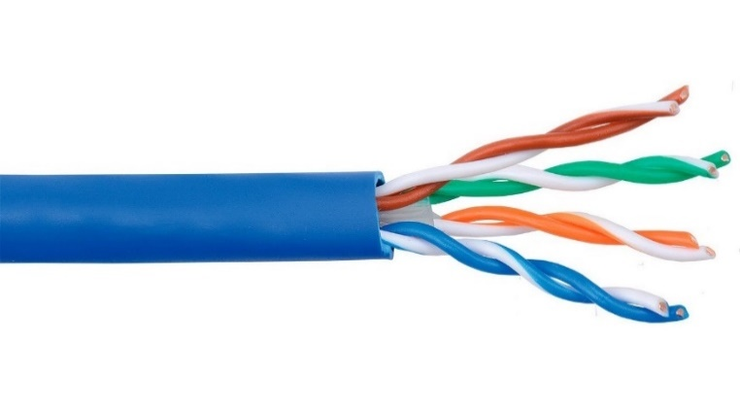

Fig.1. Unshielded twisted pair cable (UTP)
- Shielded Twisted Pair (STP): Like UTP but with additional shielding to further reduce electromagnetic interference.
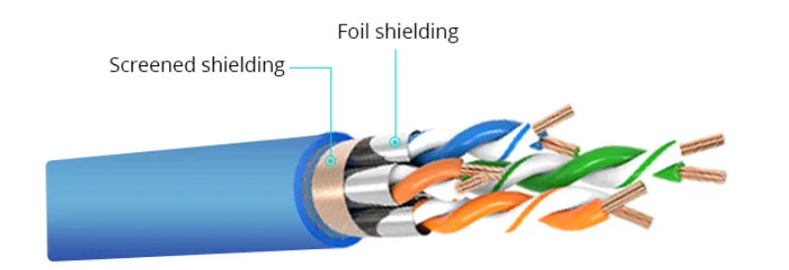

Fig.2. Shielded Twisted Pair (STP)

2. Coaxial Cables
Coaxial cable, commonly referred to as coax, is a type of electrical cable designed for transmitting radio frequency (RF) signals. It consists of a central conductor, usually made of copper, surrounded by an insulating layer, which is then encased in a concentric conductive shield. This shield is typically made of braided copper or aluminum, and the entire assembly is protected by an outer insulating jacket. The term "coaxial" refers to the geometric arrangement of the inner conductor and the outer shield, which share a common axis.
2.1 Structure and Functionality
The construction of coaxial cable allows it to effectively transmit signals while minimizing interference. The central conductor carries the electrical signal, while the insulating layer maintains the necessary spacing and prevents short circuits. The outer shield serves to block external electromagnetic interference (EMI), ensuring that the signal remains clear and undistorted. This design is particularly beneficial for high-frequency applications, as it allows for low-loss transmission over considerable distances.
2.2 Key Components
- Inner Conductor: Typically a solid or stranded copper wire that transmits the signal.
- Dielectric Insulator: A non-conductive material that separates the inner conductor from the outer shield.
- Outer Shield: Made of braided copper or aluminum, it protects against EMI and provides grounding.
- Outer Jacket: A protective layer that shields the internal components from physical damage.
2.3 Applications
- Coaxial cables are widely used in various applications, including:
- Cable Television: Connecting cable service providers to homes and businesses.
- Internet: Used by broadband providers for data transmission.
- Telephone Systems: Connecting central offices to local telephone poles.
- Radio Frequency Transmission: Linking transmitters and receivers to antennas.
- Computer Networking: Historically used in Ethernet connections, though largely supplanted by twisted pair cables and fiber optics in modern networks.
2.4 Types of Coaxial Cables
There are several types of coaxial cables, each suited for different applications:
- RG-6: Commonly used for cable television and internet connections, effective for shorter distances.
- RG-11: Used for longer runs due to its superior performance over greater distances.
- Hard-line Coaxial: Utilizes a solid copper tube for high-power applications, often in commercial broadcasting.
- Triaxial Cable: Features an additional layer of shielding for enhanced protection against interference.
Coaxial cables provide a reliable method for transmitting data, video, and voice communications, making them a staple in both residential and commercial settings. Despite the rise of optical fiber technology, coaxial cables remain prevalent due to their effectiveness and ease of installation.
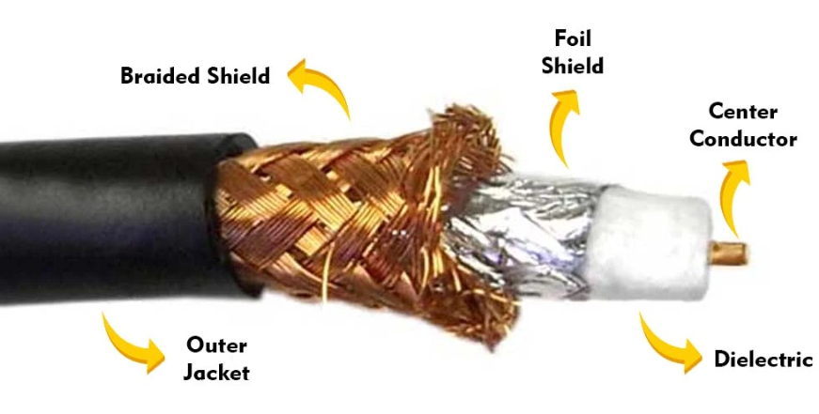

Fig.3. Coaxial Cables
3. Fiber Optic Cables
Fiber optic cables are advanced transmission mediums that utilize thin strands of glass or plastic fibers to transmit data as light pulses. This technology has transformed communication by enabling high-speed data transfer over long distances with minimal loss.

3.1 Structure and Components
A typical fiber optic cable consists of three main components:
- Core: The innermost part where the light travels. It is made of glass or plastic and is designed to carry light signals.
- Cladding: Surrounding the core, this layer has a lower refractive index, which allows for total internal reflection of light, keeping the light confined within the core.
- Buffer Coating: This protective layer surrounds the cladding, providing additional protection against physical damage.
- Outer Jacket: The outermost layer that shields the entire assembly from environmental factors.
3.2 Working Principle
Fiber optic cables transmit data by sending light signals through the core. The light reflects off the core-cladding boundary in a zig-zag manner due to the principle of total internal reflection. This allows the signals to travel long distances without significant degradation. The speed of light in fiber optics is approximately 30% slower than in a vacuum, typically around 180,000 to 200,000 km/s.
3.3 Advantages
Fiber optic cables offer several benefits over traditional copper cables:
- Higher Bandwidth: They can support significantly higher data rates, making them suitable for high-performance networking.
- Long-Distance Transmission: Fiber optics can transmit data over much longer distances without the need for signal boosting.
- Immunity to Electromagnetic Interference: Unlike copper cables, fiber optics are not affected by electromagnetic interference, ensuring clearer signals
- Durability and Lightweight: Fiber optic cables are thinner and lighter than copper wires, making them easier to install and manage.
3.4 Applications
Fiber optic cables are widely used across various industries, including:
- Telecommunications: Providing internet, television, and telephone services with high-speed connections.
- Medical: Used in imaging devices, endoscopes, and surgical instruments due to their ability to transmit light without interference.
- Military and Aerospace: For secure communications and data transfer in challenging environments.
- Undersea Communications: Fiber optic cables are essential for global internet connectivity, as they can be laid on the ocean floor.
Overall, fiber optic technology continues to play a crucial role in modern communication systems, enabling faster and more reliable connectivity across various sectors.
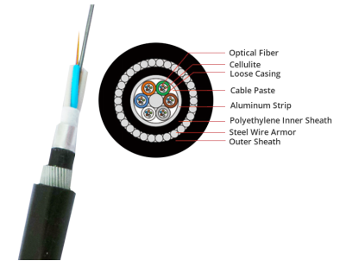

Fig.4. Fiber Optic Cables
4. Network cable connectors
Network cable connectors are devices that establish a physical connection between network cables and networking devices, such as computers, routers, and switches. They are crucial for enabling the transfer of data across various types of networks. Different types of connectors are designed to work with specific cable types and networking standards.
4.1 Common Types of Network Cable Connectors
1.RJ-45 Connector:
- The most widely used connector for Ethernet cables.
- It has eight pins and is used for connecting devices in Local Area Networks (LANs).
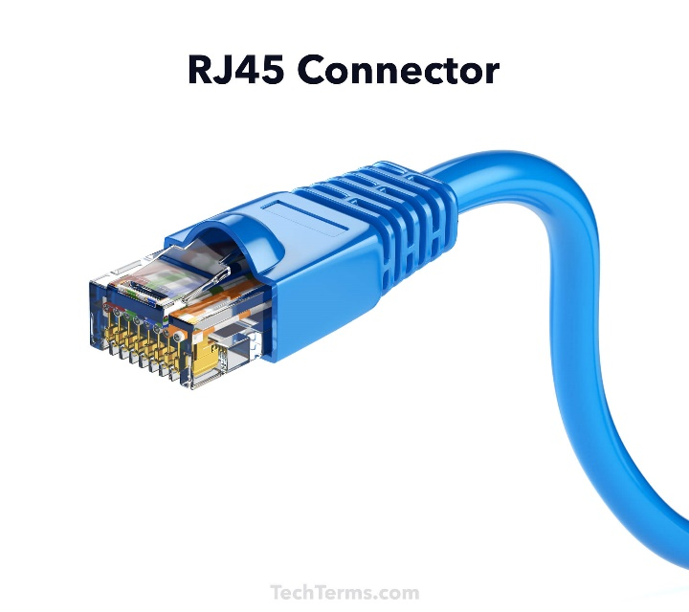

Fig.4. RJ-45 Connector
2. BNC Connector:
- Commonly used with coaxial cables in older networking technologies.
- Suitable for applications such as CCTV systems.
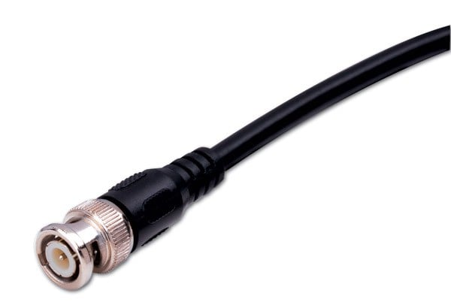

Fig.5. BNC Connector
3. Fiber Optic Connectors:
- Includes types like Square Connector (SC) 2.5, Lucent Connector (LC) 1.25 mm, and Straight Tip (ST) 2.5mm connectors.
- Used for connecting fiber optic cables, which transmit data using light signals.
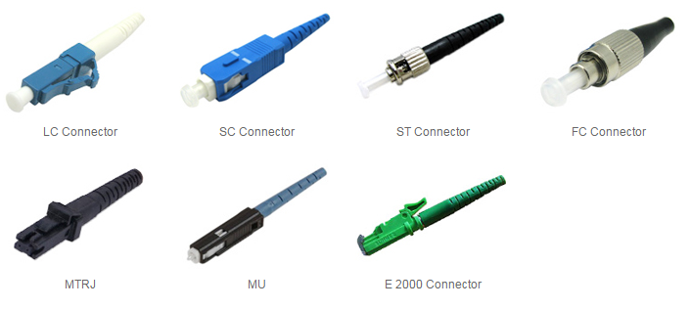

Fig.6. Fiber Optic Connector

4. USB Connector:
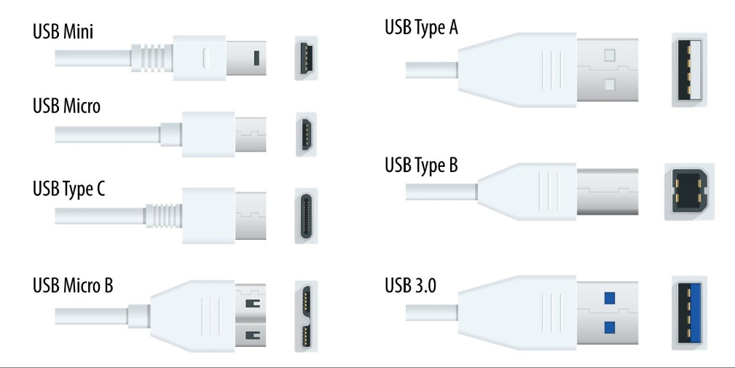
- Primarily used for connecting peripherals but can also facilitate networking, such as connecting a computer to a modem or router.
Fig.7. USB Connector
5. HDMI Connector:
- Used for high-definition multimedia interface connections, mainly for audio and video transmission.
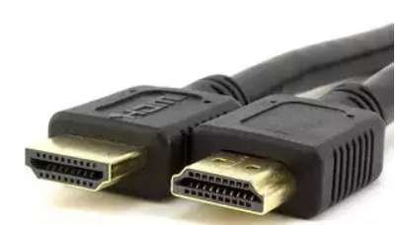

Fig.7. HDMI Connector
6. Difference of Straight Through, Crossover, and Rollover Wiring
A Straight-through cable is a type of twisted pair cable commonly used in local area networks (LANs) to connect devices of different types. It is designed to facilitate the transmission of data between devices, such as connecting a computer to a network switch, router, or hub.
6.1 Characteristics of Straight-Through Cables
Wiring Standards: Straight-through cables are wired using either the T568A or T568B wiring standards, with both ends of the cable having the same pin arrangement. This means that the pinouts on both ends are identical, allowing for a direct one-to-one connection of transmit and receive signals.
6.2 Common Uses: These cables are typically employed in scenarios where devices of different functions need to be connected. Examples include:
- Connecting a computer to a switch or hub.
- Linking a router's WAN port to a DSL or cable modem.
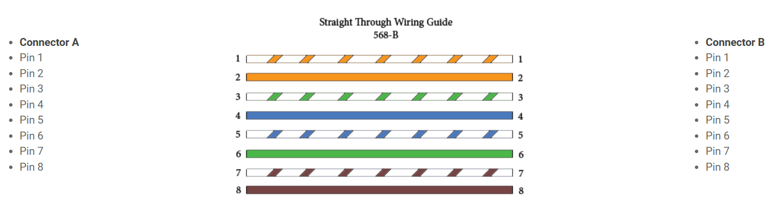
- Connect two different types of devices, such as a computer to a network printer.

Fig.8. Straight Through Wiring Guide
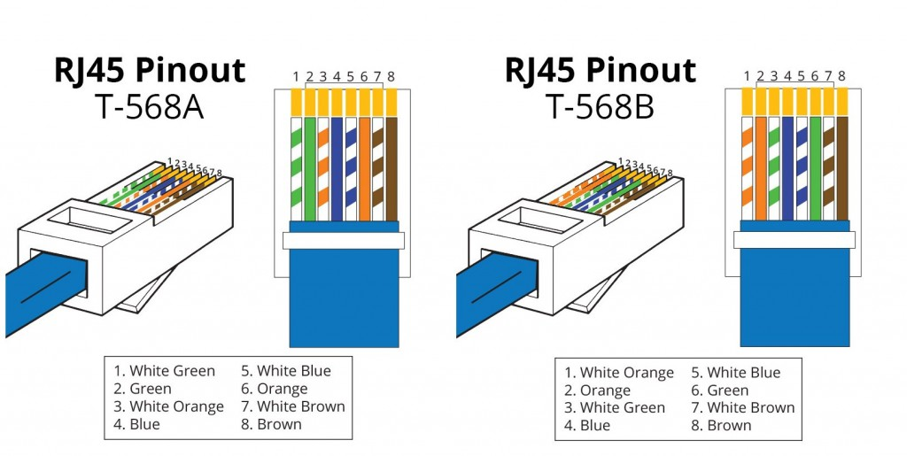
Fig.9. Straight Through Wiring Guide T-568A and T-568B

7. Crossover Cable
Crossover wired cables (commonly called crossover cables) are very much like straight-through cables with the exception that TX and RX lines are crossed (they are at opposite positions on either end of the cable. Using the 568-B standard as an example below, you will see that Pin 1 on connector A goes to Pin 3 on connector B. Pin 2 on connector A goes to Pin 6 on connector B, etc. Crossover cables are most commonly used to connect two hosts directly. Examples would be connecting a computer directly to another computer, connecting a switch directly to another switch, or connecting a router to a router. Note: While in the past, when connecting two host devices directly, a crossover cable was required. Nowadays, most devices have auto-sensing technology that detects the cable and device and crosses pairs when needed.
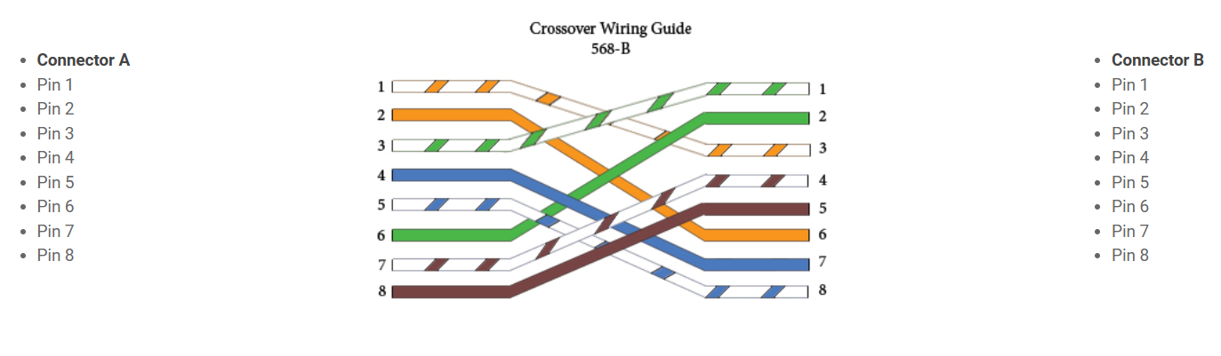
Fig.8. Crossover Wiring Guide
8. Rollover Wired Cables
Rollover wired cables, most commonly called rollover cables, have opposite Pin assignments on each end of the cable or, in other words, it is "rolled over." Pin 1 of connector A would be connected to Pin 8 of connector B. Pin 2 of connector A would be connected to Pin 7 of connector B and so on. Rollover cables, sometimes referred to as Yost cables are most commonly used to connect to a device's console port to make programming changes to the device. Unlike crossover and straight-wired cables, rollover cables are not intended to carry data but instead create an interface with the device.
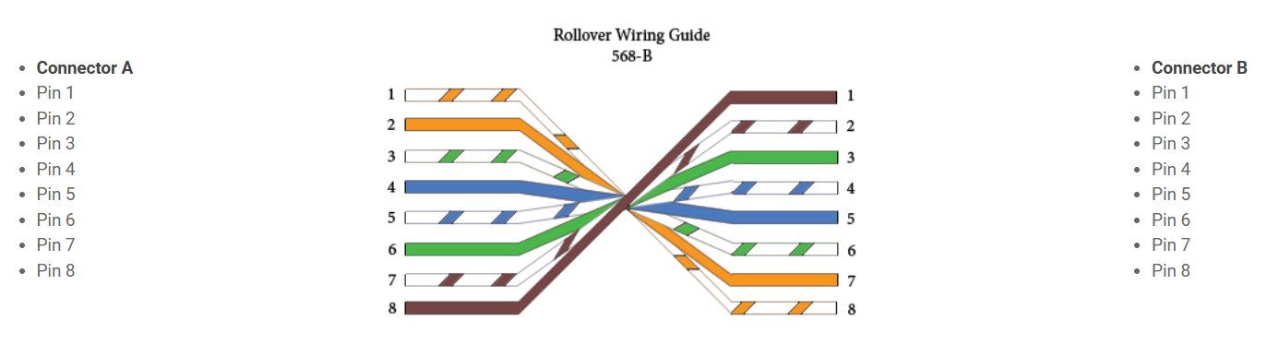
Fig.8. Rollover Wiring Guide
9. Network Cable installation mechanism
Network cable installation involves several key mechanisms and best practices to ensure efficient connectivity and performance. Here’s an overview of the installation process and the components involved.
9.1 Overview of Network Cabling
Network cabling is the method of connecting devices to facilitate data transfer. It can be categorized into wired and wireless systems, with wired connections often preferred for their reliability and speed, especially in business environments

9.2 Installation Mechanism
Components of Structured Cabling
Structured cabling is a standardized approach that integrates various media types (voice, data, video) into a cohesive system. It consists of several key subsystems:
- Demarcation Point: This is where the service provider's network connects to the customer's network.
- Equipment Rooms: These are designated areas for housing cables and networking equipment, serving as consolidation points.
- Vertical Cabling: This involves connections within the equipment rooms, typically running vertically between floors.
- Horizontal Cabling: Wires that connect telecommunications rooms to individual workstations, usually routed through ceilings or walls.
- Work Area Components: These connect end-user devices to the horizontal cabling systems.
10. Straight Through vs Crossover Cable, which to choose?
Straight through vs crossover cable, which one should I choose? Usually, straight-through cables are primarily used for connecting unlike devices. And crossover cables are used for connecting alike devices.
Use straight-through Ethernet cables for the following cabling:
- Switch to router
- Switch to PC or server
- Hub to PC or server
Use crossover cables for the following cabling:
- Switch to switch
- Switch to hub
- Hub to hub
- Router to router
- Router Ethernet port to PC NIC
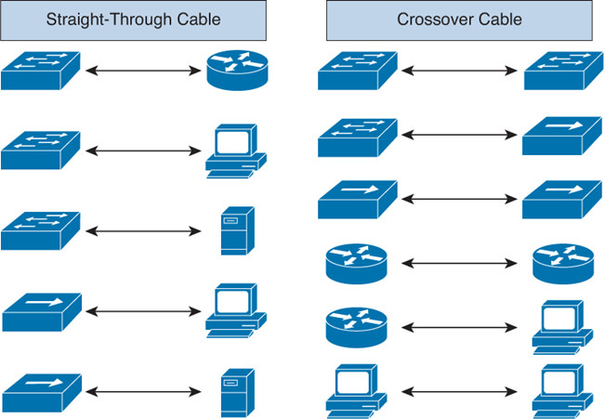
- PC to PC

Installation Steps
- Planning: Assess the network requirements, including the number of devices, types of services (data, voice), and future scalability.
- Design: Create a layout that includes the placement of cables, equipment rooms, and workstations, ensuring compliance with local codes and standards.
- Cable Installation: Install the chosen cables according to the design. This includes running cables through walls, ceilings, and floors, ensuring proper support and avoiding interference.
- Termination: Connect the cables to jacks and patch panels. This step requires careful handling to maintain signal integrity.
- Testing: Conduct tests to verify that the installation meets performance standards. This includes checking for continuity, signal strength, and any potential interference.
- Documentation: Maintain records of the installation, including cable types, lengths, and test results, for future reference and troubleshooting. The installation of network cabling is a critical process that requires careful planning and execution. By following structured cabling principles and best practices, organizations can ensure a robust and efficient network infrastructure that meets current and future communication needs.
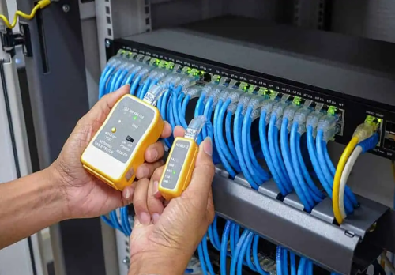
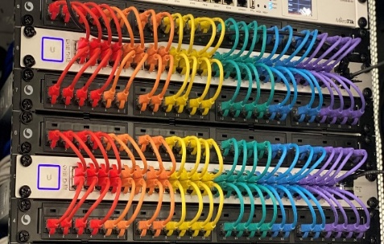
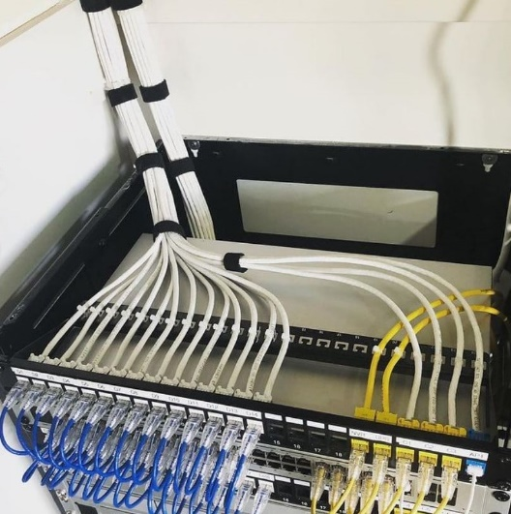
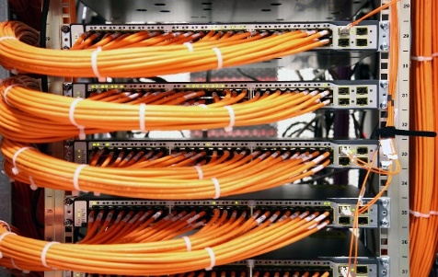
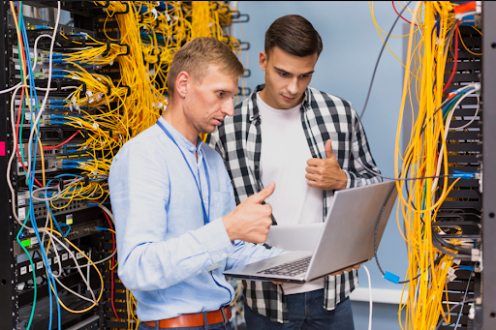

Fig.9. Overview of Network Cabling Installation Mechanism

Lab Activities

Activity 1: Understanding Cable Specifications
Step 1: Identify Different Types of Cables
- Cat5e: Enhanced Category 5, supports up to 1 Gbps over 100 meters.
- Cat6: Category 6 supports up to 10 Gbps over 55 meters.
- Cat6a: Augmented Category 6, supports up to 10 Gbps over 100 meters.
Step 2: Read and Record Specifications
- Use datasheets or online resources to find and record the specifications for each type of cable.
Step 3: Examine Physical Differences
- Observe the physical differences in cable thickness, shielding, and twists per inch.

Student Assessment:
Objective: Test students' understanding of cable types, specifications, and installation concepts.
Questions:
- Explain the difference between Cat5e, Cat6, and Cat6a cables in terms of performance, speed, and usage.
- Define the following terms:
  - Shielded Twisted Pair (STP)
  - Unshielded Twisted Pair (UTP)
- What are the main factors to consider when choosing a cable for a specific network environment?
- List and explain two common issues that occur during cable installation.
- Describe how a cable tester can be used to check the functionality of a network cable.
- Why is it important to use a cable tester after crimping a new cable? Explain the potential issues it helps avoid.
- Describe a situation where a cable tester might not detect a problem, but the cable still doesn't function correctly. What other tools or methods could you use to diagnose the issue?
Cisco Packet Tracer Activity Tasks
Step 1: Setting Up a Basic Network (Cable Installation)
- Open Cisco Packet Tracer.
- Add the following devices to the workspace:
  - 3 PCs (PC0 and PC1, PC2)
  - 1 Switch (Switch0)
- Connect the devices using the appropriate cables:
  - PC0 to Switch0: Straight-through Cable
  - PC1 to Switch0: Straight-through Cable
  - PC2 to Switch0: Straight-through Cable
- Assign the following IP addresses:
  - PC0: 192.168.1.1 /24
  - PC1: 192.168.1.2 /24
  - PC1: 192.168.1.3 /24
- Test connectivity Sending the Packet:
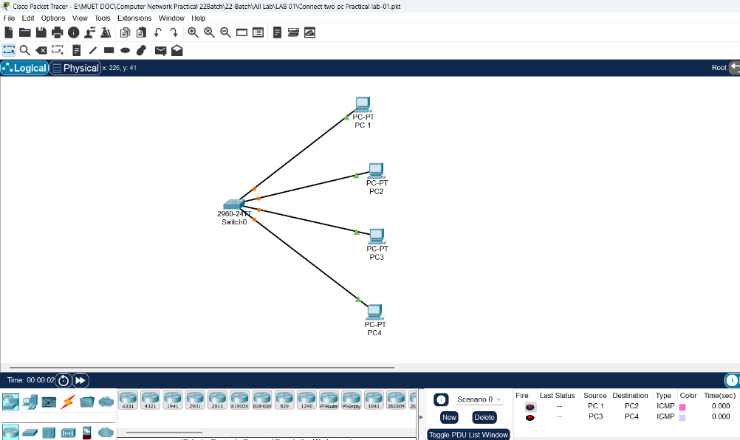
  - From PC0 to PC1.

Step 2: Troubleshooting Common Cable Issues
- Disconnect one of the cables and replace it with the wrong cable type (e.g., crossover instead of straight-through).
- Observe the status lights on the devices and test connectivity using the Ping tool.
Troubleshooting Task:
- Identify and fix the cable issue by replacing it with the correct cable type.
Learning Outcome
By completing this activity, students will gain practical experience in:
- Choosing appropriate cable types.
- Identifying and resolving common network issues.
- Using Packet Tracer tools for troubleshooting.
Submission Instructions for Packet Tracer Activity
- Activity Title: Network Cabling, Testing, and Troubleshooting.
- Submission Platform: Upload your completed Packet Tracer file (.pkt) on Google Classroom under the designated assignment post.

Guidelines
- File Naming: Name your file in the following format:
YourName_StudentID_NetworkActivity.pkt
Example: AliAhmed_ID_NetworkActivity.pkt
- Original Work:
  - Ensure that your work is entirely your own.
  - No copying from other students—strict penalties will apply for plagiarism.
- Screenshots (Optional): Attach screenshots of the completed simulation (ping results, troubleshooting steps, etc.) in a separate document if required.

Deadline
- Submit the activity on Google Classroom before [insert deadline here, e.g., December 19, 2024, at 11:59 PM.
- Late submissions will not be accepted unless prior approval is obtained.

Checklist Before Submission
- All devices are properly connected with the correct cables.
- Ping tests are successful, demonstrating network functionality.
- Errors or faults (if any) have been resolved.
- File is properly named and uploaded in .pkt format.

THE END

Student Assessment:
Objective: Test students' understanding of cable types, specifications, and installation concepts.
Questions:
- Explain the difference between Cat5e, Cat6, and Cat6a cables in terms of performance, speed, and usage.

Difference between Cat5e, Cat6, and Cat6a cables:
Feature | Cat5e | Cat6 | Cat6a
Maximum Speed | 1 Gbps | 1–10 Gbps | 10 Gbps
Maximum Bandwidth | 100 MHz | 250 MHz | 500 MHz
Maximum Distance | 100 meters | 100 m (1 Gbps), ~55 m (10 Gbps) | 100 meters
Interference Protection | Basic | Better than Cat5e | Very high
Usage | Home & small offices | Offices, campus networks | Data centers, high-speed enterprise networks
Explanation:
- Cat5e is suitable for basic networking and internet usage.
- Cat6 supports higher speeds with reduced crosstalk, ideal for modern offices.
- Cat6a is designed for high-performance networks where speed and reliability are critical.
- Define the following terms:
  - Shielded Twisted Pair (STP)
  - Unshielded Twisted Pair (UTP)

a. Shielded Twisted Pair (STP)
Shielded Twisted Pair (STP) is a type of twisted-pair cable that includes additional shielding around the wire pairs. This shielding helps reduce electromagnetic interference (EMI) and crosstalk. STP cables are commonly used in industrial environments and data centers where electrical noise is high.

b. Unshielded Twisted Pair (UTP)
Unshielded Twisted Pair (UTP) is a twisted-pair cable without any extra shielding. It relies on the twisting of wire pairs to reduce interference. UTP cables are cost-effective, lightweight, and easy to install, making them the most commonly used cables in LAN networks.
- What are the main factors to consider when choosing a cable for a specific network environment?

Factors to consider when choosing a network cable
When selecting a network cable, the following factors should be considered:
- Required speed and bandwidth – Higher data rates require higher category cables such as Cat6 or Cat6a.
- Distance – Longer cable runs require cables that can maintain signal quality over distance.
- Network environment – Noisy environments may require shielded cables (STP).
- Cost – Higher category cables are more expensive.
- Future expansion – Choosing higher-grade cables supports future network upgrades.
- List and explain two common issues that occur during cable installation.

Two common issues during cable installation

1. Incorrect termination
If the wires are not arranged according to T568A or T568B standards, the cable may not function properly or may cause network errors.

2. Physical damage to the cable
Excessive bending, pulling, or crushing of the cable can damage internal wires, resulting in signal loss or intermittent connectivity.
- Describe how a cable tester can be used to check the functionality of a network cable.

How a cable tester checks network cable functionality
A cable tester:
- Sends signals through each wire inside the cable
- Verifies correct wire order (pin-out)
- Detects open circuits, short circuits, crossed pairs, or split pairs
- Confirms cable continuity and connection quality
This ensures the cable can properly transmit data.
- Why is it important to use a cable tester after crimping a new cable? Explain the potential issues it helps avoid.
Using a cable tester after crimping:
- Confirms that all wires are properly connected
- Prevents network downtime due to faulty cables
- Detects wiring mistakes early
- Saves time and troubleshooting effort
Potential issues avoided:
- No network connection
- Slow data transfer
- Packet loss
- Intermittent connectivity
- Describe a situation where a cable tester might not detect a problem, but the cable still doesn't function correctly. What other tools or methods could you use to diagnose the issue?

Situation where a cable tester may not detect a problem
Example Situation:
A cable tester shows the cable is correct, but the network connection is slow or unstable.
Possible hidden problems:
- Electromagnetic interference (EMI)
- Cable length exceeding recommended limits
- Poor-quality cable material
- Network device configuration issues

Other tools or methods to diagnose the issue:
- Network analyzer or packet sniffer (e.g., Wireshark)
- Checking switch/router ports
- Testing cable under actual network load
- Replacing the cable temporarily to compare performance

---END--

